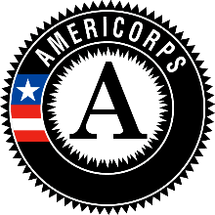

Alternative Service Plan of Activities Template
Below are changes to the scope of the activities being performed by Missouri AmeriCorps Members serving with our AmeriCorps State program.

The awarded sub-grantee to which this notification applies is:

GRANT NUMBER

LEGAL APPLICANT NAME

NUMBER OF MEMBERS INVOLVED (include number of total slots not MSYs)

THE TYPES OF SERVICE THAT MEMBERS MAY BE PERFORMING IN RESPONSE TO EXTRANEOUS CIRCUMSTANCES

DATE SUBMITTED

DATE APPROVED BY CNCS

NAME OF CNCS PROGRAM OFFICER

NAME OF MCSC PROGRAM OFFICER

Disclaimer: Prohibited Activities must still be adhered to and alternative service activities must in no way change the program scope or design.

